PKF WEBSITE PROOFREAD
FOR ALL PICTURES: once I get access to Naveen’s pictures again, I can assign
Assuming we are following British English of course!
Legend:
Just highlighted- corrected
Highlight with red remark- needs correction or a suggestion
Just red- comments

Corrected Introduction:

Staying at Philipkutty's Farm is an excellent opportunity to enjoy the real Keralan experience in a fascinating location, with a caring family to look after you. It is a special place, offering something different, especially for those who prefer small, friendly places, and it is the perfect hideaway for the bespoke traveller.
You are welcomed, looked after, and cared for by the family (myself, Anu, my mother-in-law Aniamma, my son Philip and my daughter, Anya). The homestay concept, and the vision behind our approach to welcoming and hosting our guests are/is entirely due to the inspirational thinking of my late husband, Vinod. I now strive to keep that vision alive and adapt to the ever-changing world we all live in, with the constant support of my staff and family.
Your privacy is assured, as the waterfront villas are entirely separate from the family residence, and independent of one another. The first villa, designed by Karl Damscen, a Swiss architect, is a traditionally styled, antique-filled, open-plan bungalow, with sufficient space for two people and an extra bed if needed. The other villas, designed by Thomas Dominic, are in the same decorative style, but with separate bedrooms, living rooms and a sit-out facing the peaceful, palm-fringed waterfront.
All this is set on a beautiful farm island reclaimed from the backwaters of Lake Vembanad in the early 1950s by my late husband's grandfather. The working farm, which practices sustainable organic farming, is two metres below the lake level and produces coconut, banana, fruit, and vegetables. Accessible by road up to the bank opposite the farm and villas, it is our vallam (country boat) that will finally take you and your luggage across the wide backwater to our island.

Pictures- we can replace some pictures of the cottages with updates pictures. For both interiors and exteriors like the ones below.

Cookery Holiday
Should we put a picture of the cooking so it’s more relevant?

The Philipkutty's Farm Cookery Holiday is a unique opportunity to learn the art of traditional Kerala home cooking — not in a hotel demonstration kitchen, but in a real family kitchen, with a real family, using ingredients fresh from the farm and local markets.
The programme is led by Aniamma, whose lifelong mastery of Kerala cuisine stems from ( we can use result of also, just a suggestion) decades of daily cooking for her family. She teaches not just recipes but technique, instinct, and the deep knowledge of spice combinations, coconut milk preparation, and slow-cooked curries that define this extraordinary culinary tradition.
A typical cookery day begins with a visit to the local market to select fresh fish, vegetables, and spices ( need to make it super clear that’s not part of the cookery demo, even though we mention in the next line ). Back at the farm, guests join Aniamma in the kitchen for a hands-on (should we mention hands on since it technically isn’t hands on, more of. A demo? Lets not over promise and under deliver!) session preparing a full Kerala meal. You will learn to make coconut milk from scratch, grind fresh spice pastes, and cook classic dishes such as fish curry in raw mango, prawn mappas, chicken stew with appam, avial, and various rice preparations. The meal you prepare is then eaten together.
Sessions can be tailored to your interests and dietary preferences — vegetarian menus, seafood-focused menus, or a broad introduction to Kerala cooking are all possible.
The cookery holiday is best enjoyed as a minimum three-night stay, allowing time for more than one cooking session as well as the broader pleasures of the farm. It is suitable for all levels of cooking experience, from complete beginners to experienced cooks who want to deepen their knowledge of South Indian cuisine.
Please mention your interest in the cookery programme when making your reservation so we can plan accordingly.

Note: we can also add a few pictures from cooking demos below the description to give guests an idea of how it comes along
Retreat
Philipkutty's Farm offers the ideal setting for a personal retreat. The combination of total privacy, extraordinary natural beauty, the rhythms of a working farm, and the warm yet unobtrusive hospitality of the family creates a space where it is genuinely possible to slow down, rest deeply, and return to yourself.
There is no formal retreat programme — no scheduled sessions, no group activities, no agenda. The retreat is simply the experience of being here: waking to birdsong over the backwaters, eating fresh, nourishing food prepared with care, spending long quiet hours on the waterfront, walking through the farm, and sleeping well.
Guests who come for retreat purposes are welcomed with particular sensitivity to their need for quiet and privacy. Meals can be taken in the villa if preferred, rather than in the shared pavilion. The family is always present but never intrusive.
For those who practise yoga or meditation, the thatched pavilion (isn’t it the jetty we are talking about, pavilion we never do yoga) overlooking the water is an exceptional space for morning practice. The farm's early-morning atmosphere -mist on the water, the sound of birds, the absence of traffic or crowds — is conducive to the kind of inner stillness hard (took out the “that is “ we can put it back also) to find in ordinary life.
We recommend a minimum stay of four nights for a retreat visit, though a week or more is even better. Many guests who come for retreats return again, drawn back by the particular quality of peace that the farm offers.
If you have specific requirements — dietary, spatial, or otherwise — please share them when making your reservation, and we will do our best to accommodate them.

Reviews – no changes ( just pictures for all we can rework )
Under review’s, we are saying this line:
Philipkutty's Farm has been welcoming guests from around the world for many years. Here is a small selection of what they have said.

Should we quantify it? Since the 2000’s or for the last 25 years?

Reservations-
Picture change
We are mentioning villa preference however we aren’t specifying which villa is what in our gallery. Are we going to do that?
Pros:
- Gives the guest a choice to their villa and be very satisfied
- Ideal for picky guests

Cons:
- Might be a hassle to always meet their requirement of villa
- Especially since amma does the assigning of villas very close to the date
Alternative we can do:
- Give the option for family villa or normal villa
- This way families/ groups are given the chance to choose

Contact Us-
Should we explicitly mention we have WhatsApp on the mentioned number?
Since it’s getting increasingly popular to contact via WhatsApp
Pros: guests might appreciate ease of early communication
Cons: it’s a hassle and eod we always communicate and finalise using email

Kerala & the Backwaters
Kerala, on the south-west coast of India, is a narrow, fertile strip of land between the Western Ghats and the Arabian Sea. Known as God's Own Country, it is a state of extraordinary natural beauty — lush paddy fields, winding waterways, coconut groves, hill stations draped in tea and spice plantations, and long golden beaches.
The backwaters are one of Kerala's most defining features: a vast network of interconnected canals, rivers, lakes, and inlets formed by 44 rivers descending from the Western Ghats. Lake Vembanad, at the heart of this system, is the longest lake in India and the setting for Philipkutty's Farm.
Life along the backwaters has its own ancient rhythm. Fishermen cast their Chinese fishing nets at dawn, houseboats drift through narrow canals lined with palms, and farmers tend land that in many places lies below sea level, protected by a centuries-old system of dykes and bunds. It is a world apart — peaceful, unhurried, and deeply beautiful.
- Kuttanad, ( are we technically in kuttanad or it okay to say we are in kuttand on a broader geographical sense?) where the farm is located, is sometimes called the Rice Bowl of Kerala. It is one of the few places in the world where farming is done below sea level. The region is famous for its snake boat races, held during the Onam festival, and for the sheer abundance of its birdlife — kingfishers, egrets, cormorants, and the occasional osprey are regular visitors to the waterfront.( Is the last sentence too long? Should we split into 2 sentences?)

Host and Family
Picture of amma and ammamma
Note: Should we metion about appa, so all 3 geenrations are covered and his kerashree award maybe?
Philipkutty's Farm is run by Anu Mathew Philip and her family. The farm and its hospitality vision were conceived by her late husband, Vinod Philip( not vinod Mathew ?), whose grandfather originally reclaimed the island from the backwaters in the 1950s. Vinod had a rare gift for making every guest feel at home — not as a customer, but as a friend — and that spirit continues to define everything about the farm today.

Anu is supported by her mother-in-law Aniamma, whose warmth and traditional Kerala cooking are beloved by guests from around the world. Her son Philip and daughter Anya are also part of the family team, carrying forward the next generation of the farm's story.

The staff, many of whom have been with the family for years, share the same values: genuine care, quiet attentiveness, and an unhurried willingness to help guests discover the real Kerala. There are no scripted greetings or service manuals here — just honest, heartfelt hospitality rooted in place and family.

Guests are looked after with great care, but also given the privacy and independence to enjoy the farm on their own terms. You might be invited to join the family for a cup of tea, or to watch the evening meal being prepared in the kitchen. Or you might simply wish to sit on your villa's sit-out as the sun sets over the water. Both are equally welcome.

Alternative way of putting it the highlighted above:
You can join the family for a cup of tea, or to watch the evening meal being prepared in the kitchen.
Or you could sit on your villa's sit-out as the sun sets over the water.

The Farm

The island on which Philipkutty's Farm stands was reclaimed from the backwaters of Lake Vembanad in the early 1950s by Philipkutty ( Mathew not Philipkutty), the grandfather of Vinod Philip. It was an extraordinary feat of labour and ingenuity: earth was brought in by boat, dykes were constructed, and slowly a productive agricultural island emerged from the water.
Today, the farm covers several acres and is farmed using sustainable and largely organic methods. The land sits two metres below the lake's level — held back by a system of dykes and pumps that requires( require) constant attention. Coconut palms, banana plants, papaya, vegetables, and a variety of tropical fruit trees grow in abundance.
Walking through the farm is a genuine pleasure. The paths wind between palm groves and paddy fields( we don’t have paddy fields on the island), past the family's small vegetable garden and the pond where lotus flowers bloom in season. Birds are everywhere: kingfishers dart low over the water, egrets stand motionless in the shallows, and the air is filled with the sound of weaver birds ( do we have weaver birds in the backwaters? We don’t have them in pkf for sure ) building their hanging nests.
The produce from the farm finds its way to the guest table (can we say lazy susan, or do we need to give context?). Coconuts are harvested fresh, bananas are picked ripe, and whatever vegetables are in season will likely appear in the day's cooking. It is a genuinely working farm, not a decorative backdrop, and guests are welcome to explore it at any time.

Farm land picture can also be changed- looks quite dated.

Villas

All the villas are spacious, independent and located on the outer dyke facing the peaceful backwaters. The villas are named after popular local flowers, trees and birds. The first villa, designed by Swiss architect Karl Damscen, is an open plan. The other villas, designed by Thomas Dominic from Kochi, have separate living rooms, bedrooms and sit-outs.

The villas are furnished with antiques, including some beautifully carved and crafted doors and windows, which were meticulously collected over time. TV and a land-line telephone are available at our residence, whilst ceiling fans assure a cooling circulation of air at all times ( should we mention about the ceiling fans in the next line with the ac, is it a little out of context? ) .

We have installed air-conditioners within the cottages for your comfort. An Internet facility through Wi-Fi (is that the best way of putting it? Can it be rephrased) is available free of cost to the guests. There is a refrigerator and an electric kettle in each room with tea and coffee-making provisions. The villas are well furnished, with two large single beds, a wardrobe, a cupboard, a writing table, a chair and settees and chairs in the sit-out. Each villa has a clean, dry, and spacious bathroom. Extra beds are available if needed, and there is also a generator to backup the electricity in case of a power failure. All windows are netted to prevent insect entry.

There are plenty of doors and windows in each villa (18 windows and 8 doors) which open onto/to the farm, garden and backwaters, allowing for excellent circulation of fresh breezes and fascinating views from within. This is in keeping with the tradition of typical backwater bungalows. The idea has been to make each villa an integral part of the surroundings so that by living in one, you are not cut off from nature, but feel at one with the beautiful environment.

The floor is finished in rustic clay tiles and the ceiling in wood. There is also a small verandah, finished in traditional red-oxide which runs around each villa.

To complement the villas, there is a beautiful thatched pavilion on stilts, overlooking the farm with views of the backwaters. We are also delighted to announce the completion of our new jetty — a covered pavilion built on the quayside where you can sit, admire the stunning views, watch the occasional houseboat glide by, or just relax and soak up your surroundings.

Note: Remove the 2 dated pictures from the album (last 2 to be precise).If we decide to show each cottage, we can design a feature where they click the name and pictures of the respective villa pops up!
Food:

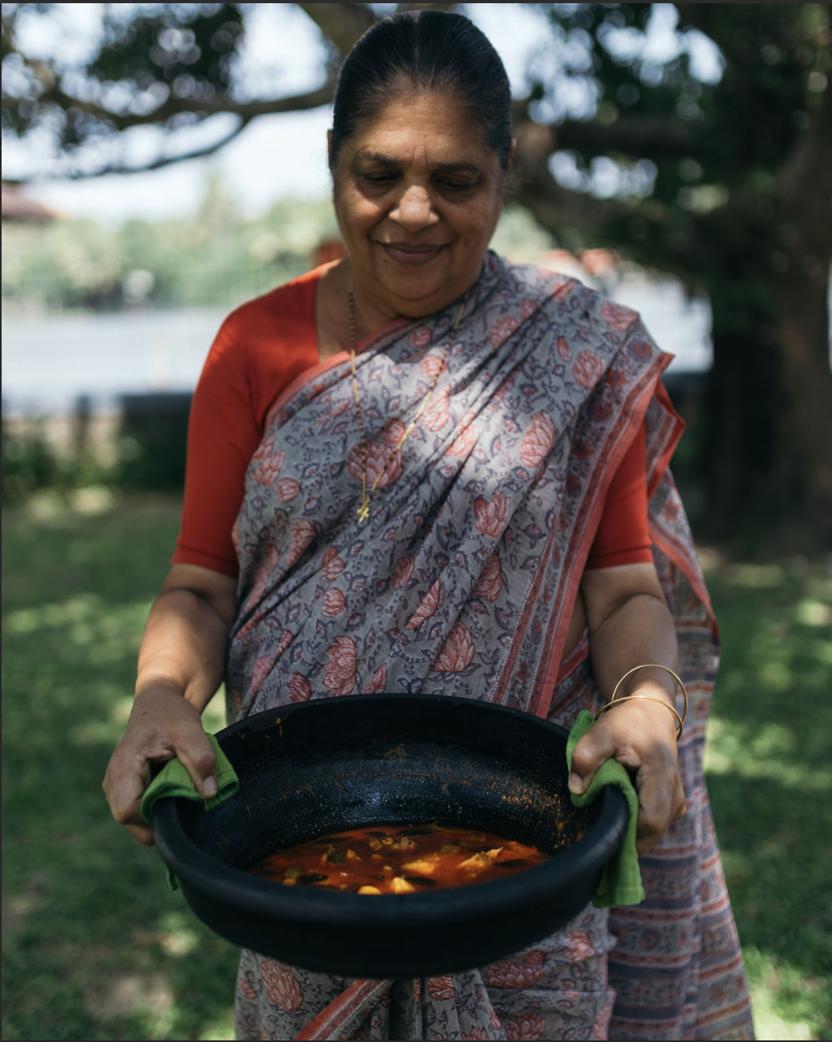

Again, replace cover picture with something more relevant like above option

Food at Philipkutty's Farm is one of the great pleasures of a stay here. Aniamma — Anu's mother-in-law — is the presiding spirit of the kitchen, and her cooking represents the very best of traditional Kerala home cooking: fresh, fragrant, cooked with care, and deeply rooted in the seasons and the land.
Meals are served in the thatched pavilion overlooking the backwaters(should we mention a line about the lazy Susan and the communal dining aspect here ?), or on the jetty if the evening is fine( we should find a better way to phrase this, we cants just say if evening is fine. Instead we can maybe say if the weather is permitting or something along those lines ). Breakfast might include fresh fruit from the farm, appam with coconut milk, egg roast, and strong South Indian coffee. Lunch and dinner draw on the full range of Kerala's extraordinary culinary tradition: fish curry cooked in raw mango and coconut, prawn mappas, duck roast, avial, thorans, and freshly made rice or appam.
Almost everything is made from scratch, with ingredients sourced from the farm or from local markets and fishermen. The coconut milk is freshly pressed each morning. The spice pastes are ground by hand. The fish is the catch of the day from the backwaters or the nearby sea.
Guests with dietary requirements — vegetarian, vegan, or otherwise — are happily accommodated. Just let the family know in advance and the kitchen will prepare something equally delicious.
The cookery holiday programme offers a more immersive experience, with hands-on (should we mention hands on since it technically isn’t hands on, more of. A demo? Lets not over promise and under deliver !) sessions in the kitchen learning to prepare traditional Kerala dishes under Aniamma's expert guidance.

ACTIVITIES
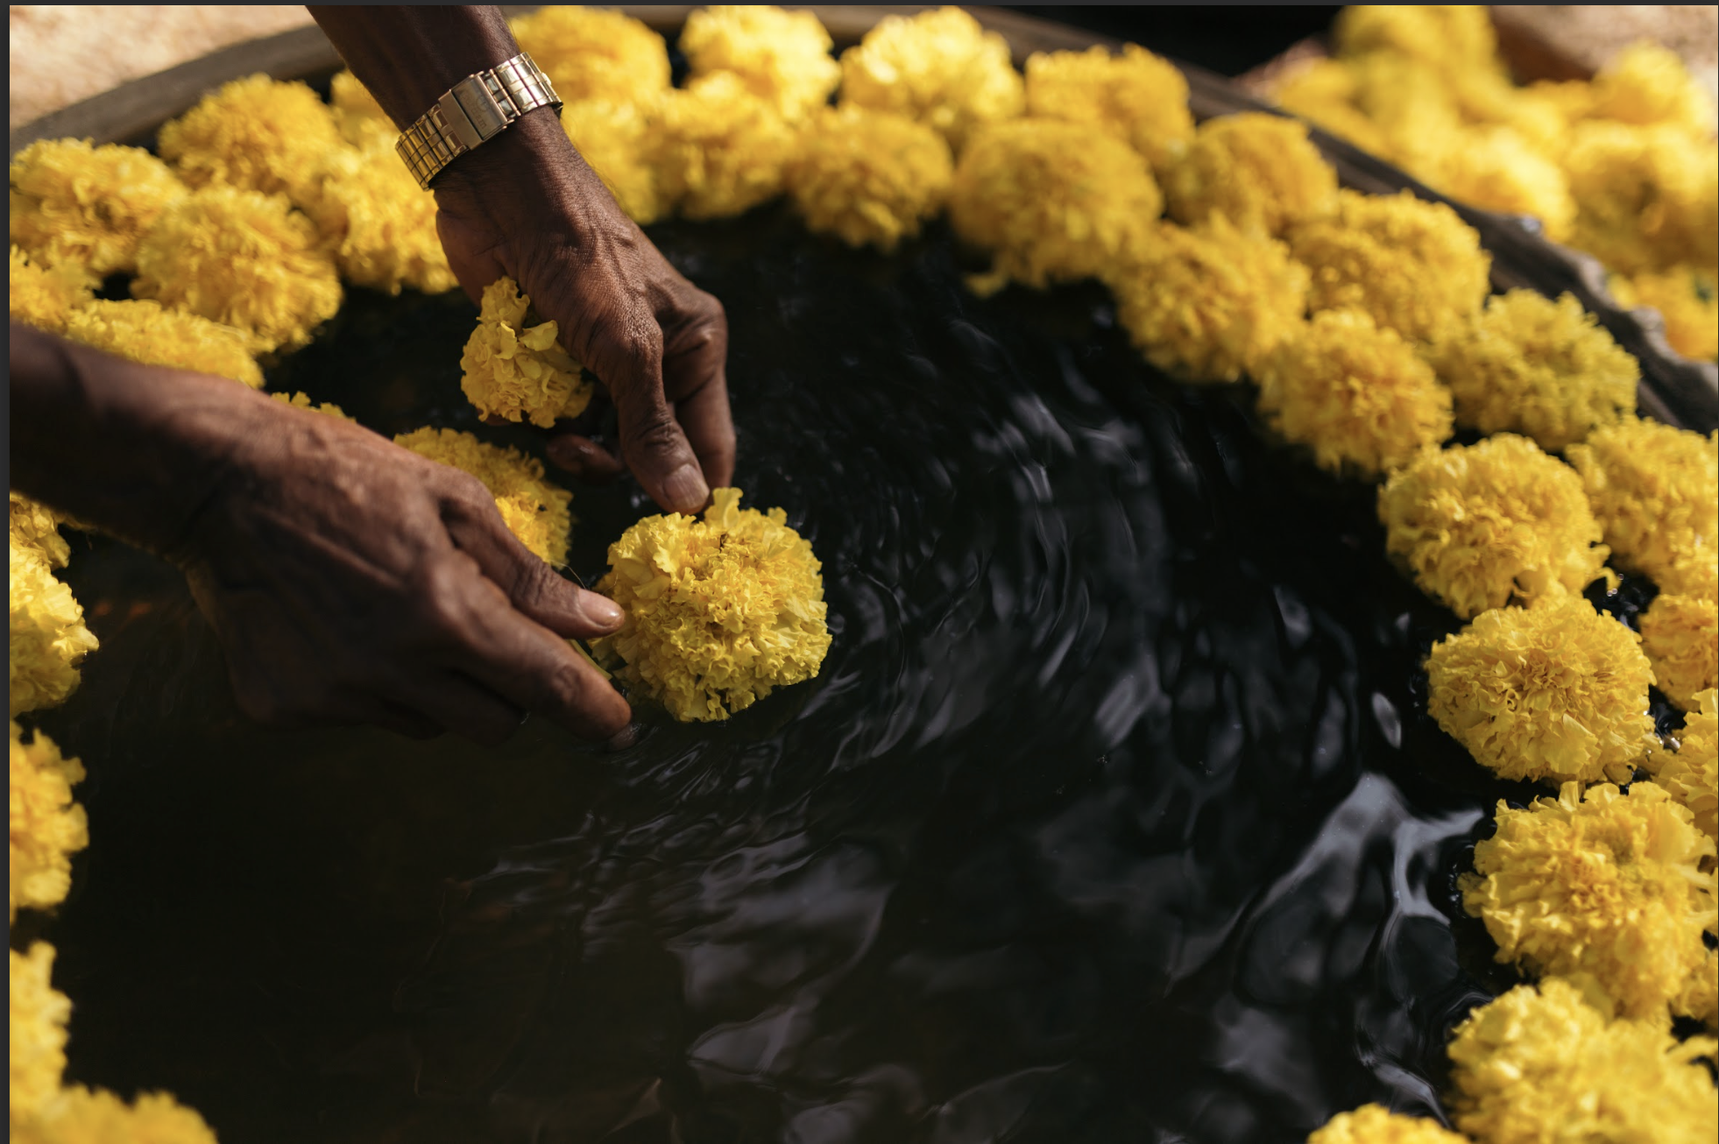

Maybe find a different cover picture, more relevant to the heading like the one above is just an example.

There is no shortage of things to do at Philipkutty's Farm — though doing very little is also entirely acceptable, and many guests find that simply sitting on their villa's waterfront sit-out, watching the light change over the backwaters, is the best activity of all.

Boat Rides
Our traditional vallam (country boat) is available for leisurely trips through the backwater channels, past paddy fields and coconut groves, to neighbouring villages and churches. Sunrise and sunset are particularly magical times to be on the water. A longer houseboat excursion can also be arranged.

( for the above we should distinguish between sunset cruise on the vallam, backwater cruise through the narrow canals on the shikara boat and thirdly the houseboat option; since we wont be able to show our guests the paddy fields on the vallam ).

Farm Walks
Guided walks through the farm with a member of the family or staff, learning about the crops, the history of the island's reclamation, and the traditional farming methods still used today.

Birdwatching
The farm and its surroundings are excellent for birdwatching. Kingfishers, egrets, cormorants, darters, moorhens, ( check with amma the most popular species we spot and mention them here ) and many other species are resident, and the winter months bring migratory visitors. A pair of binoculars is recommended.

Fishing
Traditional backwater fishing can be arranged. Chinese dip nets are still used by local fishermen, and guests are welcome to try their hand. ( we don’t have the option for the Chinese fishing nets anymore, do we still mention?)

Local Excursions
The family can arrange visits to nearby towns like Kottayam, Alleppey, and Changanacherry — for their churches, markets, and cultural sites. Longer excursions to Periyar Wildlife Sanctuary, Munnar tea estates, or the beaches of Kovalam can also be organised.

Cooking Classes
Learn to prepare traditional Kerala dishes with Aniamma in the family kitchen. See the Cookery Holiday page for details.

Saree draping, choir making, etc are some more we don’t need to mention just putting it here for reference.

Tips & Suggestions

Getting Here
The farm is located near Vechoor in Kottayam District, Kerala. The nearest airport is Cochin International Airport (75 kms). Trains run to Kottayam station (20 kms) and Cherthala station (9 kms). Taxis and auto-rickshaws are available from both stations. The family can arrange a pickup from the airport or station in advance—kindly request for the pickup when making your reservation.

The final approach is part of the adventure: you will be met at the bank opposite the farm and transferred across the backwater by vallam (country boat), along with your luggage.

What to Bring
Light, breathable clothing is advisable year-round. The evenings can be cooler between November and February — a light layer is useful. Comfortable walking shoes or sandals for farm walks. Insect repellent is recommended, especially at dawn and dusk. Sunscreen and a hat for daytime.

Best Time to Visit
October to March is the most comfortable season — warm but not oppressive, with clear skies and low humidity. April and May are hot. The monsoon runs from June to September and brings dramatic skies, heavy rain, and lush greenery. The farm is beautiful in the monsoon but some activities may be limited.

Connectivity
Wi-Fi is available free of charge and can best be accessed from the porch area, the sitting room, and the waterside jetty. Mobile signal is generally good. Indian SIM cards with data plans are inexpensive and widely available at airports.

Health & Safety
Drinking water is provided in sealed bottles. The farm tap water is not recommended for drinking. A private hospital is 9 kms away in Cherthala. The family keeps a basic first-aid kit and can assist with any medical emergency.

Currency
India is still largely cash-based in rural areas. Bring sufficient Indian Rupees. The nearest ATMs are in Cherthala (9 kms). Credit cards are accepted for the room tariff( do we say this? We don’t have our card mission since covid since we gave it up ).

